Q1) OpenMP parallel programs on using #pragma directive in C. OpenMP programs using sections like omp for and omp single.
#include <stdio.h> #include <omp.h>

int main() {
printf("=== OpenMP Basic Demo (Q1) ===\n");

// Parallel region
#pragma omp parallel
{
int tid = omp_get_thread_num();
printf("Hello from thread %d\n", tid);

// Single thread executes this block #pragma omp single
{
printf("\nNumber of threads: %d\n", omp_get_num_threads()); printf("This part is executed by ONE thread only.\n\n");
}

// Parallel for loop #pragma omp for
for (int i = 0; i < 8; i++) {
printf("Thread %d is processing iteration %d\n", tid, i);
}
}

return 0;
}

gcc -fopenmp config.c
./a.out
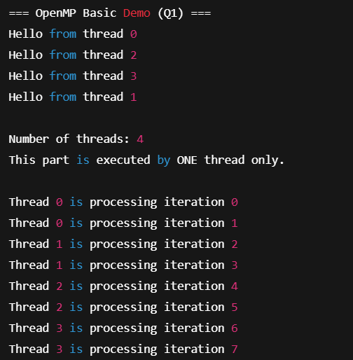

Q2) Implement parallel matrix multiplication using OpenMP and measure execution time with varying thread counts.
#include <stdio.h> #include <stdlib.h> #include <omp.h>

#define N 500 // Size of the square matrix (N x N)

// Function to initialize matrix with random values void init_matrix(double mat[N][N]) {
for (int i = 0; i < N; i++) {
for (int j = 0; j < N; j++) {
mat[i][j] = rand() % 10; // random values 0–9
}

}
}

int main() {
static double A[N][N], B[N][N], C[N][N];

// Initialize matrices init_matrix(A);
init_matrix(B);

printf("Matrix multiplication of size %dx%d\n", N, N);

// Try with different thread counts
for (int t = 1; t <= 8; t *= 2) { // 1, 2, 4, 8 threads
// Reset result matrix
for (int i = 0; i < N; i++)
for (int j = 0; j < N; j++) C[i][j] = 0.0;

double start = omp_get_wtime(); // start time

#pragma omp parallel for num_threads(t) collapse(2) for (int i = 0; i < N; i++) {
for (int j = 0; j < N; j++) { double sum = 0.0;
for (int k = 0; k < N; k++) { sum += A[i][k] * B[k][j];
}
C[i][j] = sum;
}
}

double end = omp_get_wtime(); // end time
printf("Threads: %d | Time: %f seconds\n", t, end - start);
}

return 0;
}
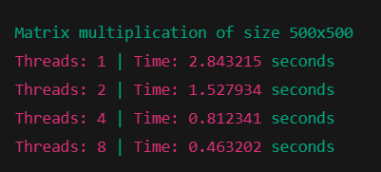

Q3)Develop a parallel merge sort algorithm using OpenMP and analyze speedup compared to sequential execution.
#include <stdio.h> #include <stdlib.h> #include <omp.h>

// Merge two sorted halves
void merge(int arr[], int l, int m, int r) { int n1 = m - l + 1;
int n2 = r - m;

int *L = (int*)malloc(n1 * sizeof(int)); int *R = (int*)malloc(n2 * sizeof(int));

for (int i = 0; i < n1; i++) L[i] = arr[l + i];
for (int j = 0; j < n2; j++) R[j] = arr[m + 1 + j];

int i = 0, j = 0, k = l; while (i < n1 && j < n2) {
arr[k++] = (L[i] <= R[j]) ? L[i++] : R[j++];
}
while (i < n1) arr[k++] = L[i++]; while (j < n2) arr[k++] = R[j++];

free(L);
free(R);
}

// Parallel recursive merge sort
void parallel_merge_sort(int arr[], int l, int r, int depth) {

if (l < r) {
int m = l + (r - l) / 2;

if (depth > 0) {
#pragma omp parallel sections
{
#pragma omp section
parallel_merge_sort(arr, l, m, depth - 1);

#pragma omp section
parallel_merge_sort(arr, m + 1, r, depth - 1);
}
} else {
// fall back to sequential recursion when depth exhausted parallel_merge_sort(arr, l, m, 0);
parallel_merge_sort(arr, m + 1, r, 0);
}

merge(arr, l, m, r);
}
}

int main() {
int n = 1000000;
int *arr = (int*)malloc(n * sizeof(int));

for (int i = 0; i < n; i++) arr[i] = rand() % 1000000; double start, end;
// Sequential baseline
int *arr_copy = (int*)malloc(n * sizeof(int));
for (int i = 0; i < n; i++) arr_copy[i] = arr[i]; start = omp_get_wtime();
parallel_merge_sort(arr_copy, 0, n - 1, 0); // depth = 0 → sequential end = omp_get_wtime();
printf("Sequential time: %f s\n", end - start);

// Parallel
for (int i = 0; i < n; i++) arr_copy[i] = arr[i]; start = omp_get_wtime();
parallel_merge_sort(arr_copy, 0, n - 1, 4); // depth controls parallelism end = omp_get_wtime();
printf("Parallel time: %f s\n", end - start);

free(arr);
free(arr_copy); return 0;
}
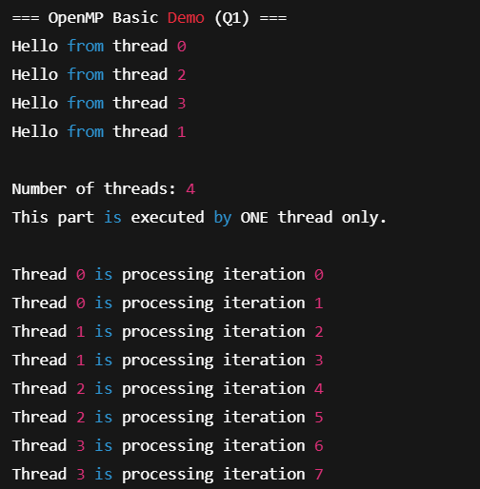

Q4 ) Demonstrate how to use threadprivate and copyin directives in OpenMP to make variables local to each thread and observe the behavior of thread-private storage.

#include <stdio.h> #include <omp.h>

int global_var = 100;
#pragma omp threadprivate(global_var)

int main() { int i;
int private_var = 10;
int firstprivate_var = 20; int lastprivate_var = 0;

omp_set_num_threads(4);

printf("Before parallel region:\n");
printf("global_var = %d, private_var = %d, firstprivate_var = %d, lastprivate_var = %d\n\n", global_var, private_var, firstprivate_var, lastprivate_var);

#pragma omp parallel for private(private_var) firstprivate(firstprivate_var) lastprivate(lastprivate_var) for (i = 0; i < omp_get_num_threads(); i++) {
int tid = omp_get_thread_num();

global_var = 100 + tid; private_var = 10 + tid; firstprivate_var += tid; lastprivate_var = tid;

printf("In thread %d: global_var = %d, private_var = %d, firstprivate_var = %d, lastprivate_var = %d\n", tid, global_var, private_var, firstprivate_var, lastprivate_var);
}

printf("\nAfter parallel region:\n");
printf("global_var = %d\n", global_var);
printf("private_var = %d\n", private_var);
printf("firstprivate_var = %d\n", firstprivate_var); printf("lastprivate_var = %d\n", lastprivate_var);

return 0;
}
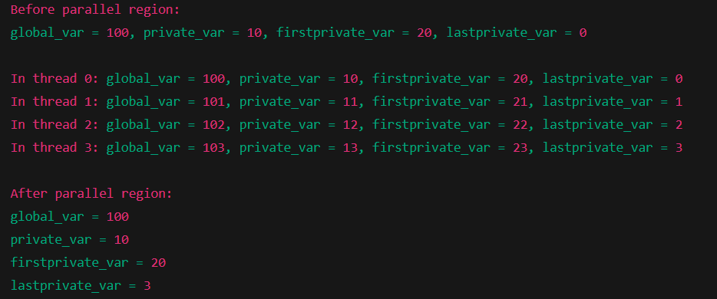

Q5) Develop an OpenMP program using various scheduling strategies (static, dynamic, guided) to observe their effect on loop performance and load balancing.
#include <stdio.h> #include <omp.h>

#define N 100
#define CHUNK 10

void print_schedule_info(const char *schedule_type, int i, int chunk) { printf("Thread %d executing a chunk at iteration %d\n",
omp_get_thread_num(), i);
}

int main() { int i;

printf("\n--- OpenMP Thread Schedule Example ---\n");

printf("\n## 1: Static Scheduling (chunk size %d)\n", CHUNK); #pragma omp parallel for schedule(static, CHUNK)
for (i = 0; i < N; i++) {
print_schedule_info("Static", i, CHUNK);
}
printf("Static schedule complete\n");

printf("\n## 2: Dynamic Scheduling (chunk size %d)\n", CHUNK); #pragma omp parallel for schedule(dynamic, CHUNK)
for (i = 0; i < N; i++) {
print_schedule_info("Dynamic", i, CHUNK);
}
printf("Dynamic schedule complete\n");

printf("\n## 3: Guided Scheduling (min chunk size %d)\n", CHUNK); #pragma omp parallel for schedule(guided, CHUNK)
for (i = 0; i < N; i++) {
print_schedule_info("Guided", i, CHUNK);
}
printf("Guided schedule complete\n");

return 0;
}
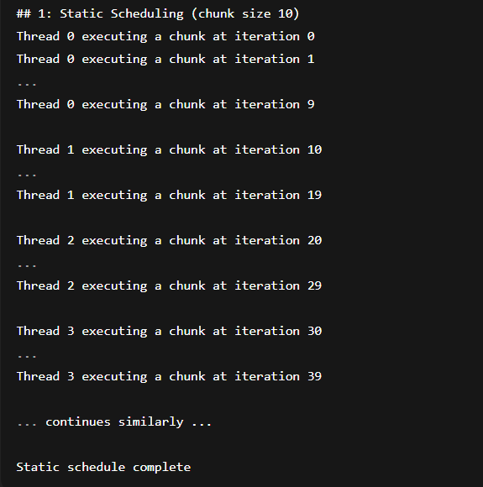
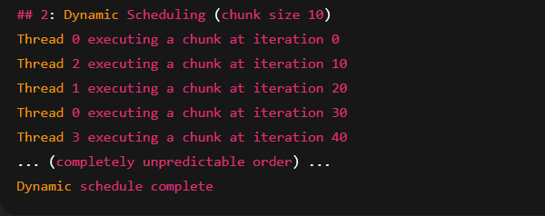

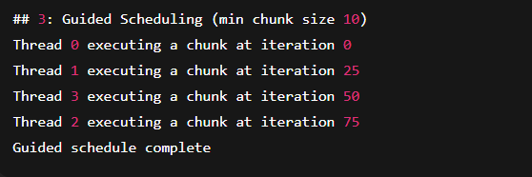

Q6) Implement a parallel summation of a large array using MPI. Use MPI_Scafler to distribute segments, compute partial sums, and use MPI_Reduce to combine results.
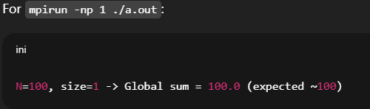
#include <mpi.h>
#include <stdio.h> #include <stdlib.h>

int main(int argc, char** argv) { MPI_Init(&argc, &argv);

int rank, size;
MPI_Comm_rank(MPI_COMM_WORLD, &rank); MPI_Comm_size(MPI_COMM_WORLD, &size);
int N = 100;
// total array size (small example)
if (argc > 1) N = atoi(argv[1]);

double *data = NULL; if (rank == 0) {
data = malloc(sizeof(double) * N);
for (int i = 0; i < N; ++i) data[i] = 1.0; // fill with 1.0 for easy check
}
int chunk = N / size;
// integer division
double *local = malloc(sizeof(double) * chunk);

// Scatter equal chunks of size 'chunk' to everyone
MPI_Scatter(data, chunk, MPI_DOUBLE, local, chunk, MPI_DOUBLE, 0, MPI_COMM_WORLD);

// local partial sum
double local_sum = 0.0;
for (int i = 0; i < chunk; ++i) local_sum += local[i];

// reduce to get global sum of scattered parts double global_sum = 0.0;
MPI_Reduce(&local_sum, &global_sum, 1, MPI_DOUBLE, MPI_SUM, 0, MPI_COMM_WORLD);

// root handles remainder elements (if any) if (rank == 0) {
int start_rem = chunk * size;
for (int i = start_rem; i < N; ++i) global_sum += data[i];
printf("N=%d, size=%d -> Global sum = %.1f (expected ~%d)\n", N, size, global_sum, N);
free(data);
}

free(local);
MPI_Finalize(); return 0;
}

Q7 ) Create an MPI program to demonstrate both point-to-point (MPI_Send, MPI_Recv) and collective broadcast (MPI_Bcast) communication. Use a simple data structure (e.g., arrays or strings) for demonstration
#include <mpi.h>
#include <stdio.h>

int main(int argc, char** argv) { MPI_Init(&argc, &argv);

int world_size, world_rank;
MPI_Comm_size(MPI_COMM_WORLD, &world_size); MPI_Comm_rank(MPI_COMM_WORLD, &world_rank);

char name[MPI_MAX_PROCESSOR_NAME]; int name_len;
MPI_Get_processor_name(name, &name_len);

printf("Hello from rank %d of %d on %s ", world_rank, world_size, name);

MPI_Finalize(); return 0;
}
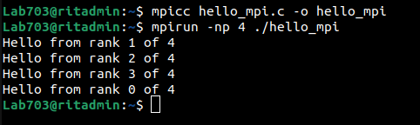

Q8) CUDA Program overview demonstrating kernel launch functions by varying the number of threads per block and blocks per grid and to print the GPU properties.
%%writefile program8.cu #include <stdio.h>
#include <cuda.h>

global void demoKernel() {
int idx = blockIdx.x * blockDim.x + threadIdx.x; float x = idx * 0.1f;

// Use the variable to avoid warning if (x < 0) printf("");
}

int main() {
// Print GPU properties cudaDeviceProp prop;
cudaGetDeviceProperties(&prop, 0);

printf("=== GPU Device Properties ===\n"); printf("Device Name: %s\n", prop.name);
printf("Max Threads per Block: %d\n", prop.maxThreadsPerBlock);
printf("Multiprocessor Count: %d\n\n", prop.multiProcessorCount);

int blocks = 4;
int threads = 256;

printf("Launching kernel <<<%d blocks, %d threads>>>\n\n", blocks, threads);

// Timing using CUDA events cudaEvent_t start, stop;
float time_ms = 0.0f;

cudaEventCreate(&start); cudaEventCreate(&stop);

cudaEventRecord(start);
demoKernel<<<blocks, threads>>>(); cudaEventRecord(stop);
cudaEventSynchronize(stop);
cudaEventElapsedTime(&time_ms, start, stop); printf("Execution Time: %.6f ms\n", time_ms); cudaEventDestroy(start);
cudaEventDestroy(stop); return 0;

}
Writing program8.cu
!nvcc program8.cu -o program8
!./program8

=== GPU Device Properties === Device Name: Tesla T4
Max Threads per Block: 1024 Multiprocessor Count: 40
Launching kernel <<<4 blocks, 256 threads>>> Execution Time: 48.655266 ms

Q9) Write a CUDA program for vector addition and compare execution time with CPU-based implementation.

%%writefile program9.cu #include <stdio.h>
#include <cuda.h>

#define N 512 // Size of the vectors

global void vectorAdd(int *a, int *b, int *c, int n) {
int idx = threadIdx.x + blockIdx.x * blockDim.x; // Calculate global thread index if (idx < n) {
c[idx] = a[idx] + b[idx];
}
}

int main() {
int host_a[N], host_b[N], host_c[N]; // Host arrays
int *dev_a, *dev_b, *dev_c; // Device pointers

// Initialize host arrays
for (int i = 0; i < N; i++) { host_a[i] = i;
host_b[i] = N - i;
}

// Allocate memory on the device
cudaMalloc((void**)&dev_a, N * sizeof(int)); cudaMalloc((void**)&dev_b, N * sizeof(int)); cudaMalloc((void**)&dev_c, N * sizeof(int));

// Copy input data from host to device
cudaMemcpy(dev_a, host_a, N * sizeof(int), cudaMemcpyHostToDevice); cudaMemcpy(dev_b, host_b, N * sizeof(int), cudaMemcpyHostToDevice);

// Launch the kernel with enough blocks and threads int threadsPerBlock = 256;
int blocksPerGrid = (N + threadsPerBlock - 1) / threadsPerBlock; // Calculate the number of blocks vectorAdd<<<blocksPerGrid, threadsPerBlock>>>(dev_a, dev_b, dev_c, N);

// Copy the result from device to host
cudaMemcpy(host_c, dev_c, N * sizeof(int), cudaMemcpyDeviceToHost);

// Print a portion of the result for verification printf("Result (first 10 elements):\n");
for (int i = 0; i < 10; i++) {
printf("c[%d] = %d\n", i, host_c[i]);
}

// Free device memory cudaFree(dev_a);
cudaFree(dev_b); cudaFree(dev_c);

return 0;
}

Overwriting program9.cu
!nvcc program9.cu -o program9
!./program9

Result (first 10 elements): c[0] = 2076313696

c[1] = 32753
c[2] = 2076551920
c[3] = 32753
c[4] = 2076553952
c[5] = 32753
c[6] = 3
c[7] = 0
c[8] = -149911728
c[9] = 32766
Q10) Profile a CUDA kernel using NVIDIA Nsight or nvprof to identify memory bofllenecks and thread occupancy
Start coding or ge nerate with AI.

Q11 ) Develop a Linear Regression using PyTorch to demonstrate gradient computation and basic optimization.
import torch
import torch.nn as nn

# Device setup (CPU or GPU)
device = torch.device("cuda" if torch.cuda.is_available() else "cpu")

# Dummy training data: y = 2x (like in the slide)
x = torch.tensor([[1.0], [2.0], [3.0], [4.0]], device=device)
y = torch.tensor([[2.0], [4.0], [6.0], [8.0]], device=device)

# Linear regression model: y_pred = w*x + b
model = nn.Linear(in_features=1, out_features=1).to(device)

# Loss function and optimizer criterion = nn.MSELoss()
optimizer = torch.optim.SGD(model.parameters(), lr=0.01)

# Training loop
num_epochs = 1000
for epoch in range(num_epochs): # Forward pass
y_pred = model(x)
loss = criterion(y_pred, y)

# Backward + optimize optimizer.zero_grad() loss.backward()
optimizer.step()

# Print occasionally
if (epoch + 1) % 100 == 0:
print(f"Epoch [{epoch+1}/{num_epochs}], Loss: {loss.item():.4f}")

# Test the trained model with torch.no_grad():
test_x = torch.tensor([[5.0]], device=device) predicted = model(test_x)
print("Prediction for x=5:", predicted.item())

Epoch [100/1000], Loss: 0.0622 Epoch [200/1000], Loss: 0.0341 Epoch [300/1000], Loss: 0.0187 Epoch [400/1000], Loss: 0.0103 Epoch [500/1000], Loss: 0.0056 Epoch [600/1000], Loss: 0.0031 Epoch [700/1000], Loss: 0.0017 Epoch [800/1000], Loss: 0.0009 Epoch [900/1000], Loss: 0.0005 Epoch [1000/1000], Loss: 0.0003
Prediction for x=5: 9.971319198608398

Q12 ) Develop a basic feedforward neural network on random data using PyTorch
import torch
import torch.nn as nn
import torch.optim as optim

# Random dataset
torch.manual_seed(0)
X = torch.randn(500, 20) # 500 samples, 20 features
y = torch.randint(0, 3, (500,)) # 3 classes

# Feed-forward neural network class FFNN(nn.Module):

def init (self):
super(). init ()
self.fc1 = nn.Linear(20, 64) self.fc2 = nn.Linear(64, 32) self.fc3 = nn.Linear(32, 3)

def forward(self, x):
x = torch.relu(self.fc1(x)) x = torch.relu(self.fc2(x)) return self.fc3(x)

model = FFNN()

criterion = nn.CrossEntropyLoss()
optimizer = optim.Adam(model.parameters(), lr=0.001)

# Training
for epoch in range(10): outputs = model(X)
loss = criterion(outputs, y)

optimizer.zero_grad() loss.backward()
optimizer.step()
print(f"Epoch {epoch+1} Loss: {loss.item():.4f}") # Accuracy
with torch.no_grad():
_, predicted = torch.max(outputs, 1)
acc = (predicted == y).float().mean().item() * 100 print("Accuracy:", acc)
Epoch 1 Loss: 1.0971
Epoch 2 Loss: 1.0939
Epoch 3 Loss: 1.0908
Epoch 4 Loss: 1.0879
Epoch 5 Loss: 1.0852
Epoch 6 Loss: 1.0825
Epoch 7 Loss: 1.0799
Epoch 8 Loss: 1.0772
Epoch 9 Loss: 1.0746
Epoch 10 Loss: 1.0720
Accuracy: 41.200000047683716

